WorkshopPLUS – Power Apps for Power User 1 Day

Module 4.3: Build your own Power Automate flows in an easy-to-use visual designer

Student Lab Manual

*Instructor Edition (Book Title Hidden Style)*

**Conditions and Terms of Use**

Microsoft Confidential

This training package is proprietary and confidential, and is intended only for uses described in the training materials. Content and software is provided to you under a Non-Disclosure Agreement and cannot be distributed. Copying or disclosing all or any portion of the content and/or software included in such packages is strictly prohibited.

The contents of this package are for informational and training purposes only and are provided "as is" without warranty of any kind, whether express or implied, including but not limited to the implied warranties of merchantability, fitness for a particular purpose, and non-infringement.

Training package content, including URLs and other Internet Web site references, is subject to change without notice. Because Microsoft must respond to changing market conditions, the content should not be interpreted to be a commitment on the part of Microsoft, and Microsoft cannot guarantee the accuracy of any information presented after the date of publication. Unless otherwise noted, the companies, organizations, products, domain names, e-mail addresses, logos, people, places, and events depicted herein are fictitious, and no association with any real company, organization, product, domain name, e-mail address, logo, person, place, or event is intended or should be inferred.

**Copyright and Trademarks**

© 2020 Microsoft Corporation. All rights reserved.

Microsoft may have patents, patent applications, trademarks, copyrights, or other intellectual property rights covering subject matter in this document. Except as expressly provided in written license agreement from Microsoft, the furnishing of this document does not give you any license to these patents, trademarks, copyrights, or other intellectual property.

Complying with all applicable copyright laws is the responsibility of the user. Without limiting the rights under copyright, no part of this document may be reproduced, stored in or introduced into a retrieval system, or transmitted in any form or by any means (electronic, mechanical, photocopying, recording, or otherwise), or for any purpose, without the express written permission of Microsoft Corporation.

For more information, see Use of Microsoft Copyrighted Content at

<http://www.microsoft.com/en-us/legal/intellectualproperty/Permissions/default.aspx>

DirectX, Hyper-V, Internet Explorer, Microsoft, Outlook, OneDrive, SQL Server, Windows, Microsoft Azure, Windows PowerShell, Windows Server, Windows Vista, and Zune are either registered trademarks or trademarks of Microsoft Corporation in the United States and/or other countries. Other Microsoft products mentioned herein may be either registered trademarks or trademarks of Microsoft Corporation in the United States and/or other countries. All other trademarks are property of their respective owners.

**Contents**

Lab 4.3: Build your own Power Automate flows in an easy-to-use visual designer 5

Exercise 1: Add trigger to automated flow 6

Task 1: Open Power Automate Flow Designer 6

Task 2: Create Automated flow 6

Task 3: Add trigger to flow 6

Task 4: Configure trigger 7

Exercise 2: Add actions to flow 7

Task 1: Add a new step and select action 7

Task 2: Configure action 8

Exercise 3: View all your flows 9

Task 1: View flows 9

Exercise 4: View flow history 10

Task 1: View flow history 10

Exercise 5: View flow run details 11

Task 1: View flow run details 11

Lab 4.3: Build your own Power Automate flows in an easy-to-use visual designer

**Introduction**

In this lab, you will perform the actions necessary to build your own flows in an easy-to-use visual designer.

**Objectives**

After completing this lab, you will be able to:

* Add triggers to flow
* Add steps to flow
* Add Actions to flow
* Configure ‘Send an Email’ action in flow
* View all your Power Automate flows
* View flow history
* View flow run details

**Prerequisites**

Ensure you are using the “Incognito” or “InPrivate” browsing session of your modern browser.

Additionally, use the latest version of [Microsoft Edge](https://support.microsoft.com/en-us/help/4501095/download-the-new-microsoft-edge-based-on-chromium) (aka Edge Chromium) for the best performance.

**Estimated time to complete this lab**

30 mins

**Scenario**

The organization wishes to automate business process using the Power platform to take advantage of **No Code/Low Code** Power Automate. As part of this effort, you are required to create a POC to show how a user could automate a simple process.

## Exercise 1: Add trigger to automated flow

### Task 1: Open Power Automate Flow Designer

1. Open your browser using “InPrivate” and navigate to <https://flow.microsoft.com> and select **Create.**

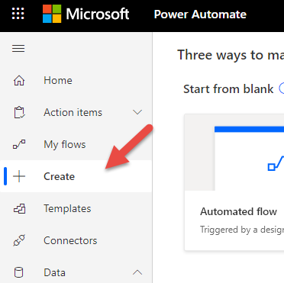

### Task 2: Create Automated flow

1. In section ‘Start from Blank’ click on **Automated flow**

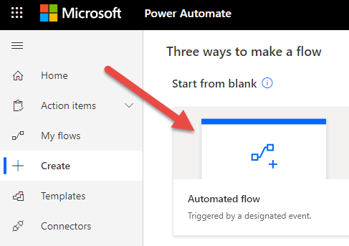

### Task 3: Add trigger to flow

1. Enter “New file alert” as flow name.
2. Search flow triggers for “When a file is created”. Note that several triggers appear to work with connectors like SharePoint, Dropbox, OneDrive, or OneDrive for Business.
3. Select OneDrive for Business “**When a file is created**.”

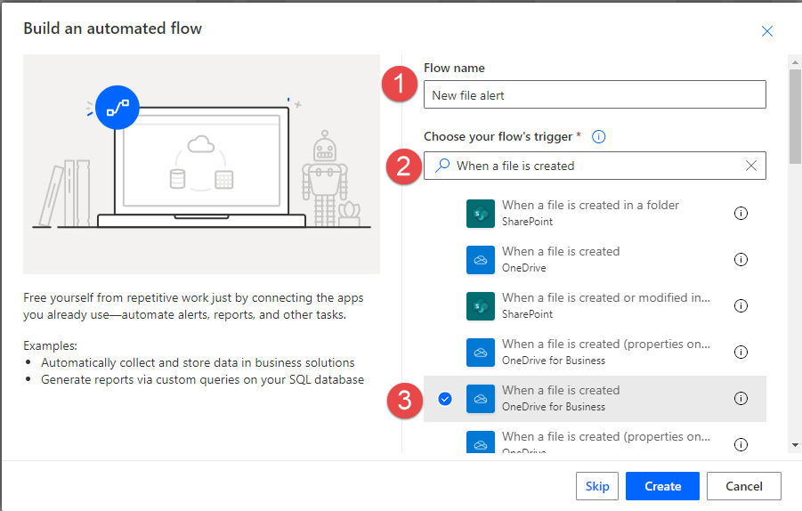

1. Select **Create**.

### Task 4: Configure trigger

**Note:** You should automatically be logged into the OneDrive for Business connector; if not, do so before proceeding.

1. Select the folder icon.
2. Select **Root** folder.

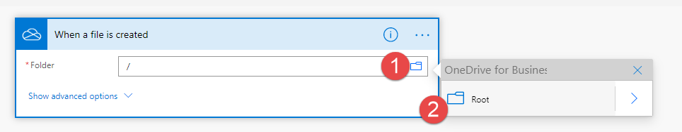

## Exercise 2: Add actions to flow

### Task 1: Add a new step and select action

1. Click on **+ New step**.
2. Search for “Send email” and select “**Send an email (V2)**.”

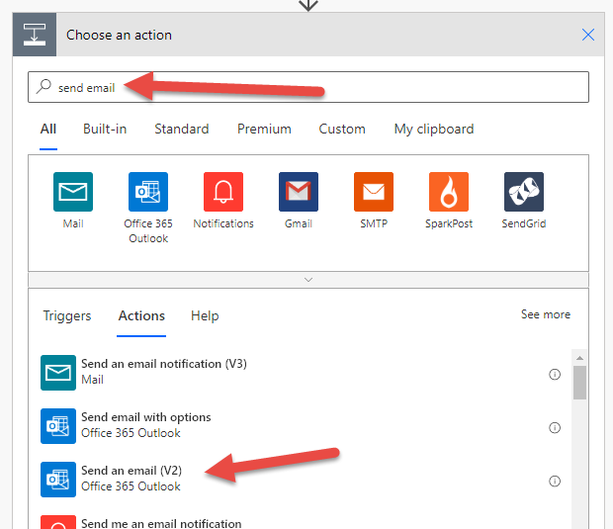

### Task 2: Configure action

1. Provide email address of all recipients (Search on administrator or other accounts created) in the To field.
2. For Subject field, select **Add dynamic content**.



1. Select the **File Name** dynamic content.

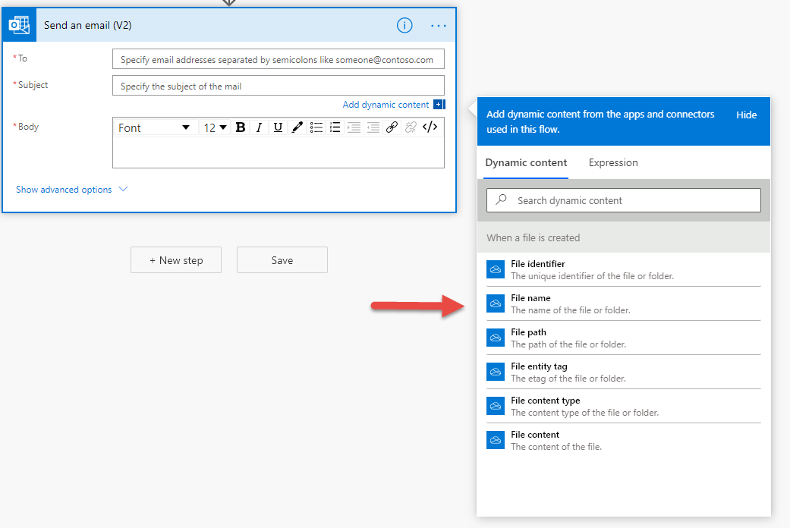

1. Complete **Subject** field by typing, “has been created in your OneDrive for Business folder.”

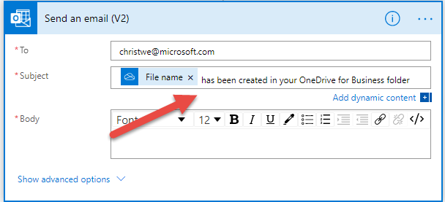

1. In **Body** field, type a comment like, “New document available.”

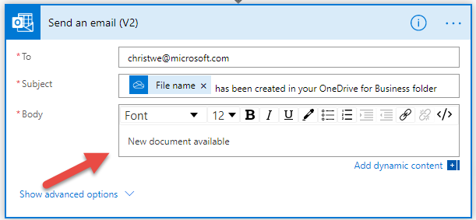

1. Click **Save**.

**Note:** If you want, you could click on “Show advanced options,” and add fields like From, CC, BCC, Importance, and Attachments.

## Exercise 3: View all your flows

### Task 1: View flows

1. Within the Power Automate studio (<https://flow.microsoft.com>), click on **My flows** on the left-hand menu.

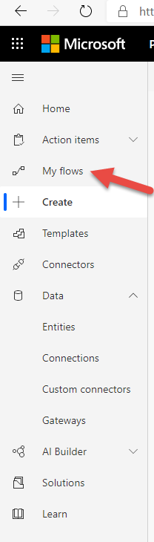

1. Browse through headings to see different flows you have created or been assigned.

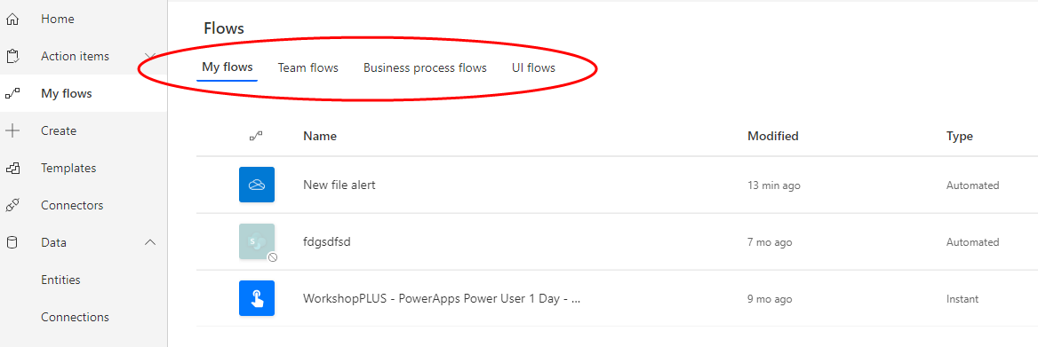

## Exercise 4: View flow history

### Task 1: View flow history

1. From **My flows** on the left-hand menu, select a flow and click on the ellipses, and select **Run history**.

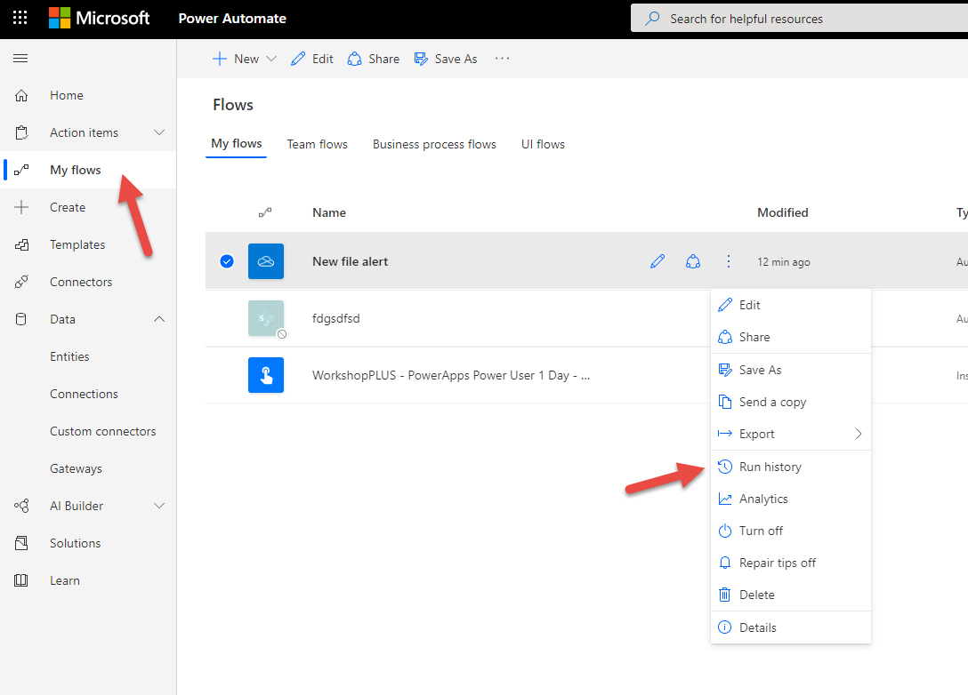

1. View run history. Note: you can export to a .csv file from here.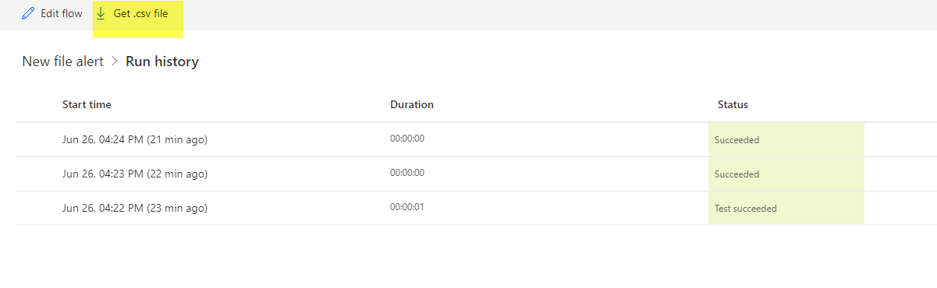

## Exercise 5: View flow run details

### Task 1: View flow run details

1. From **My flows** on the left-hand menu, select a flow and click on the ellipses, and select **Details**.

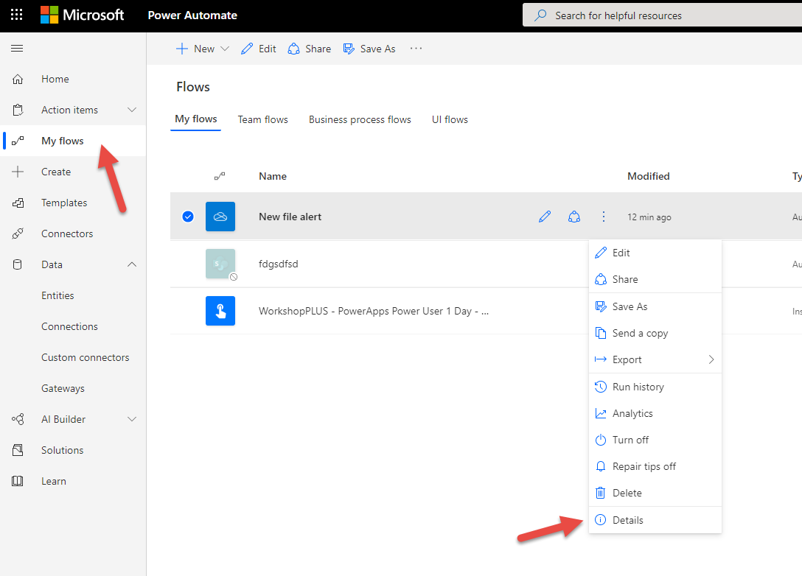

1. From the details page, you can view all details around the flow. If you want to see details for a specific run, select the timestamp.

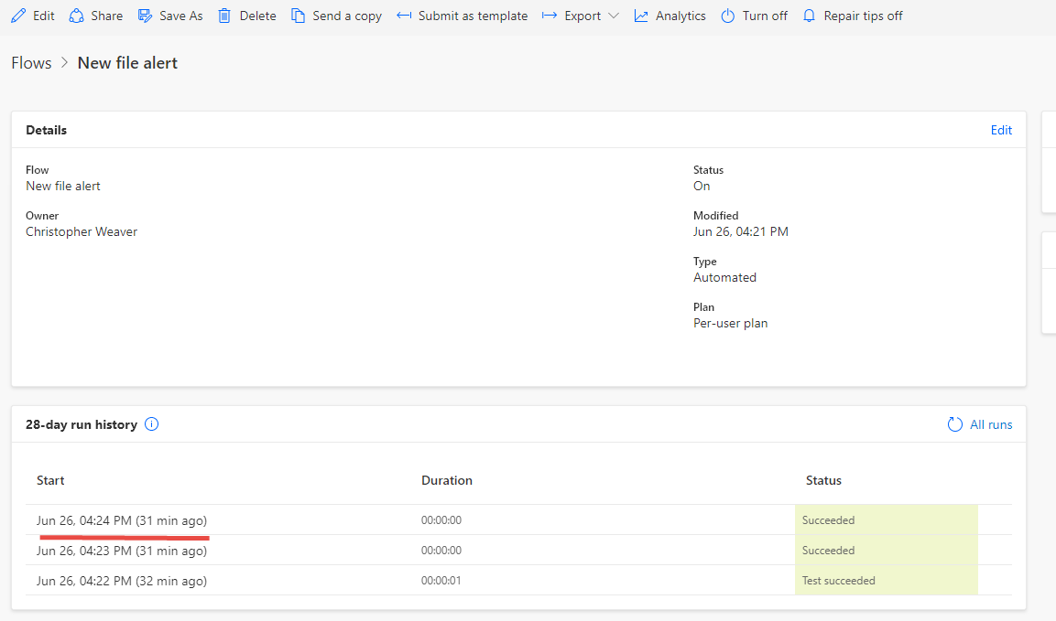

1. If you do select a run to view details, you can then expand specific triggers and actions to see what was passed between services.

